1. The code in the manual implement trapezoidal membership function. You have to re-write the code to implement triangular membership function. Plot the figure. The plot should be like this

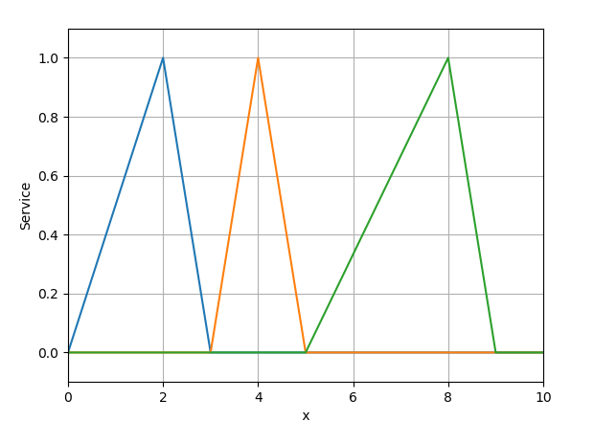.

**Code:**

import fuzzifier

import matplotlib.pyplot as plt

import numpy as np

# Demonstrates the use of Fuzzifier module to make a trapezoidal membership function

x=np.arange(0, 10.1, 0.5)

low=np.array([0,2,3,4])

middle=np.array([3,4,5,6])

high=np.array([5,8,9,10])

service=fuzzifier.Triangle(x,low,middle,high)

plt.plot(x, service.low, x, service.middle,x,service.high)

plt.ylabel('Service')

plt.xlabel(' x ')

plt.axis([0, 10, -0.1, 1.1])

plt.grid(True)

plt.show()